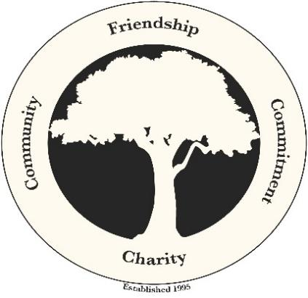

Dear Friend,

The Elmhurst Boys are holding their 9th annual charity golf tournament on Saturday June 8, 2024 at Richmond Country Club. This year’s recipients are Joe and Sheila Murphy. To know the Murphy's is to love the Murphy's. Sheila and Joe Murphy have been a pillar of the community for many, many years and now it is time to show our love. Sheila has been battling cancer for many years. Her courageous fight has been unwavering, and her internal strength is unsurpassable. Let us all stand with Sheila and Joe to fight with them and help to offset the cost associated with this battle.
Net Proceeds from past golf several tournaments, totaling over $146,000, allowed us to contributed to many worthwhile causes, including: A Wish Come True, Alexandra “Alex” Wilson, Emmanuel House in Providence, the American Red Cross, San Miquel School, First Tee, St. Pius V School, Best Buddies of RI and Rhode Island School for the Deaf. We are a 100% volunteer organization with no paid staff, thus ensuring the maximum level of funding that we can provide to charities. Visit our website at www.TheElmhurstBoys.org to learn more about our mission.

Information about this great day may also be found in our brochure, which includes a registration form. Please reserve your tee signs, a dinner seat, donate or secure a golfer registration by sending the form, or a note, by mail or online as noted below.

For mailing, please make checks payable to The Elmhurst Boys, and mail c/o Nicholas Soares, at 42 Maplecrest Ave, North Providence, RI 02911, or use our EventBrite tournament page, described below.

If you prefer to reserve by credit card, you can do so on our Eventbrite page at:
https://www.eventbrite.com/e/9th-annual-elmhurst-boys-charity-golf-tournament-tickets-868490527547?utm-campaign=social&utm-content=attendeeshare&utm-medium=discovery&utm-term=listing&utm-source=wsa&aff=ebdsshwebmobile
On behalf of the Elmhurst Boys, thank you in advance for your generous support.
Sincerely,
Thomas Zelano President, The Elmhurst Boys

John Puleo
Golf Committee Chair
Jmpuleo1@verizon.net
401-954-6735

